**ASSIGMENT 1:**

**THE UTILITY OF CREDIT CARD**



NAME: MUHAMMAD AFIQ IMRAN BIN AZIZAN

MATRIKS NO.: 286997

UNIVERSITY: UNIVERSITY UTARA MALAYSIA

CLASS: INFORMATION TECHNOLOGI, SCHOOL OF

COMPUTING

LECTURER: PROF. MADYA DR.AZMAN B YASIN

DUE DATE: 12 DECEMBER 2021

**History:**

Credit Card is a plastic containing a means of identification that could make purchase of goods and service with lending money from bank. Credit Card first invented at United State of America in 1920s because it bother company that customer purchase made by company outlets. In 20th century the uses of credit card increasing and almost all people such as university student, teacher, and worker have credit card of their own.

**PROBLEM:**

In today era a lot to be done such as paying debt, buying plane ticket, booking a hotel and a lot more and you didn’t have much money to buy it all. Furthermore, you also didn’t want to bring a lot of money in your wallet because it could be stolen by people or you will get uncomfortable with the big wallet in your pocket. Not only that, you also need to buy things at once but can’t go at one place in a single time.

**UNDERSTANDING THE PROBLEM:**

-don’t have much money to buy things

-don’t want wallet to be stolen

-don’t want to feel uncomfortable when bringing wallet

-wanting to purchase thing in short amount of time without going many places

**ALTERNATIVE TO SOLVE PROBLEM:**

-making purchases at home with online banking

-making loan with bank to get money

-bring wallet with big amount of money for example bringing RM100 instead of RM50

-using credit card to buy things online and bring it in wallet every time to purchase things

**BEST ALTERNATIVE:**

Out of all the alternative, the best one is to use credit card to buy things online and bring it in wallet every time to purchase things. The reason why pick this is because it contains the other 3 alternative to solve problem. Not only that credit card also had ability that non purchase don’t have. The thing is called cashback, cashback is an amount of percentage that will be pay back to us from purchasing something with specific type of credit cards. You also need to pay bank monthly because we borrow money from bank and if you didn’t pay them that month the debt will become bigger next month.

**INSTRUCTION:**

1. Enter your name
2. Enter your credit card number
3. Enter expiration date
4. Enter your CCV
5. Purchase the things you want
6. Purchase successful

**TYPE OF CREDIT CARD:**

|  |  |  |  |  |
| --- | --- | --- | --- | --- |
| Type of credit card | Name of credit card | Specialty | picture | Interest rate |
| Type 1 | CIMB e Credit Card | none |  | 15% |
| Type 2 | CIMB Petronas Platinum MasterCard | -Give cashback of 7% on petrol money |  | 15% |
| Type 3 | Bank Rakyat Platinum Explorer Credit Card-i | -Give cashback of 5% on airlines and hotel booking |  | 13.5% |

**CALCULATION:**

|  |  |  |
| --- | --- | --- |
| Type of credit card | calculation | Description |
| Type 1 | -smartphone = 200  -laptop = 3000  -petrol = 50  - airplaneTicket = 4556  -Insurance = 74  -houseDebt = 650  -carDebt = 494  -HotelBooking = 200  -Totalpayment = 2000 + 3000 + 50 + 2556 + 74 + 650 +  494  -monthly payment= (2000/12) + (3000/12) + (50/12) +  (2556/12) + (74/12) + (650/12) +  (494/12)  -current money = 2000  -new money = 2000 + 3500  Money left = new money – monthly payment | -Thers nothing special about credit card type A because it’s just a basic one |
| Type 2 | *same as Type A  -petrol cashback = 50 *0.07  -balance = petrol cashback + new money | -Credit Card Type B will give you back 7% of petrol money in a year |
| Type 3 | *same as Type A  -airplane ticket cashback = (airplane ticket * 0.05) (4)  -hotel booking cashback = ((hotel booking * 0.05) (4)(7))  -last balance = balance 8 + airplane ticket cashback + hotel booking cashback | - Credit Card Type C will give you back 5% of airplane ticket and hotel booking |

**CALCULATION CREDIT CARD WITH DEBT:**

Calculate in June

|  |  |  |
| --- | --- | --- |
| description | Interest rate | calculation |
| -you have amount of debt RM1000  -you spend 100 at June 10  -you spend 400 at June 20  -you spend 100 at June 30 | 20% | **Calculating DPR:**  -20/365 = 0.054%  **Monthly Interest Rate:**  0.054 * 30 = 1.62%  **June 1 – 9:**  1000 * 9 = 9000  **June 10 – 19:**  1100 * 9 = 9900  **June 20 – 29:**  1500 * 9 = 13500  **June 30:**  1600 * 1 = 1600  monthly interest rate = (9000 + 9900 + 13500 + 1600) / 30    = RM1133  **Rate:**  Rate = (1.62/100) * 1133  = 18.35 |

**Evaluate the solution:**

In conclusion, buy using credit card it can help you a lot with purchasing and pay things up in no time and make things easier for us to pay without going everyplace to get things done and waste our energy. I hope that technology in credit card will improve because it help a lot to people like us to do some payment and purchasing easier.

**ALGORITHM:**

**PSEUDOCODE:**

Start

Read name, CCnum1, CCnum2, CCnum3, CCnum4, ED, CCV

Total payment = smartphone + laptop + petrol + airplaneTicket + Insurance +

houseDebt + carDebt +HotelBooking

balance1 = limit1 -totalpayment

Output balance1

SmartphoneDebt1 = (smartphone/12)

laptopDebt1 = (laptop/12)

petrolDebt1 = (petrol/12)

airplaneTicketDebt1 = (airplaneTicket/12)

InsuranceDebt1 = (Insurance/12)

houseDebt1 = (HouseDebt/12)

carDebt1 = (carDebt/12)

HotelBookingDebt1 = (HotelBooking/12)

AllDebt1 = SmartphoneDebt1 + laptopDebt1 + petrolDebt1 + airplaneTicketDebt1

+ InsuranceDebt1 + houseDebt1 + carDebt1 + HotelBookingDebt1

Output  AllDebt1

Currentmoney = 2000

NewMoney = Currentmoney + 3500

Output “Will you pay CIMB e Credit Card debt this month?”

Output “Your unpaid Debt for this Credit Card is RM1000:

DPR = (15/365)

MonthlyInterstRate = DPR * 30

Debt1 = 1000 * 9

Debt2 = 6000 * 9

Debt3 = 7074 * 9

Debt4 = 7768 * 1

MonthlyInterest = (Debt1 + Debt2 + Debt3 + Debt4)/30

rate = (MonthlyInterest/100) * MonthlyInterestRate

Output rate

monthlydebt = AllDebt1 + rate

Output monthlydebt

Moneyleft = newMoney – monthlydebt

Output Moneyleft

Stop

**FLOWCHART:**

name, CCnum1, CCnum2, CCnum3, CCnum4, ED, CCV

Total payment = smartphone + laptop + petrol + airplaneTicket + Insurance + houseDebt + carDebt +HotelBooking

balance1 = limit1 -totalpayment

SmartphoneDebt1 = (smartphone/12)

laptopDebt1 = (laptop/12)

petrolDebt1 = (petrol/12)

airplaneTicketDebt1 = (airplaneTicket/12)

InsuranceDebt1 = (Insurance/12)

houseDebt1 = (HouseDebt/12)

carDebt1 = (carDebt/12)

HotelBookingDebt1 = (HotelBooking/12)

AllDebt1 = SmartphoneDebt1 + laptopDebt1 + petrolDebt1 + airplaneTicketDebt1

+ InsuranceDebt1 + houseDebt1 + carDebt1 + HotelBookingDebt1

Output balance1

Output AllDebt1

Currentmoney = 2000

NewMoney = Currentmoney + 3500

Output “Will you pay CIMB e Credit Card debt this month?”

Output “Your unpaid Debt for this Credit Card is RM1000:

DPR = (15/365)

MonthlyInterstRate = DPR * 30

Debt1 = 1000 * 9

Debt2 = 6000 * 9

Debt3 = 7074 * 9

Debt4 = 7768 * 1

MonthlyInterest = (Debt1 + Debt2 + Debt3 + Debt4)/30

rate = (MonthlyInterest/100) * MonthlyInterestRate

Output rate

monthlydebt = AllDebt1 + rate

Output monthlydebt

Moneyleft = newMoney – monthlydebt

Output Moneyleft

**CODING:**

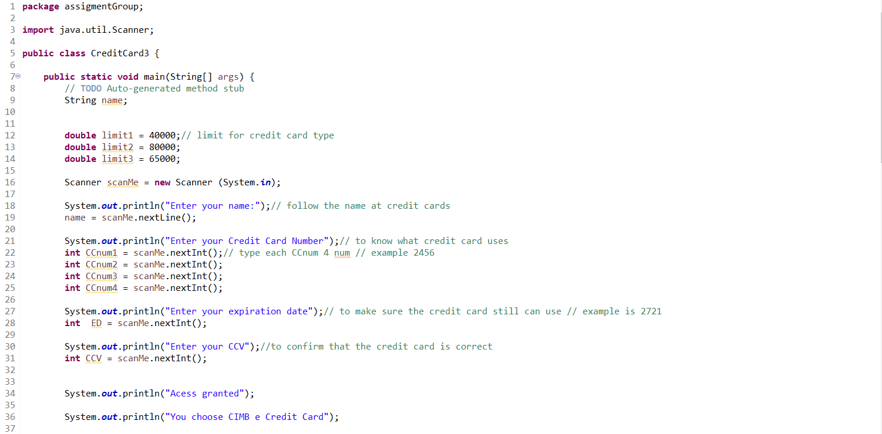

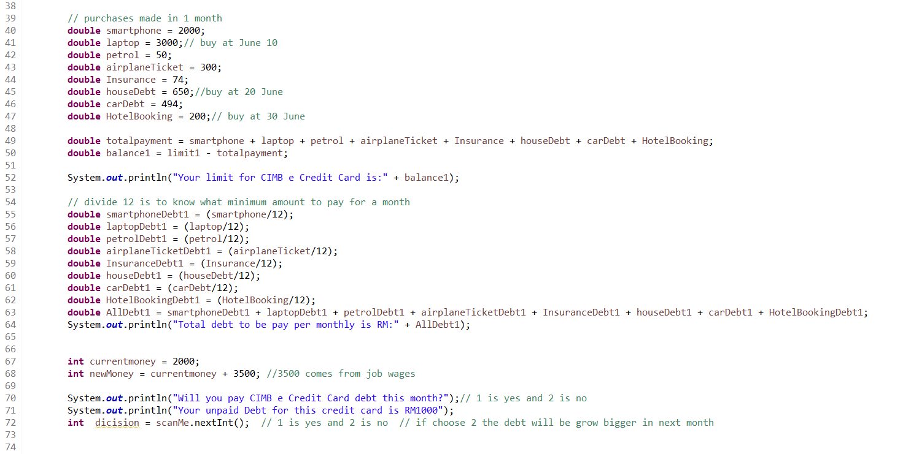

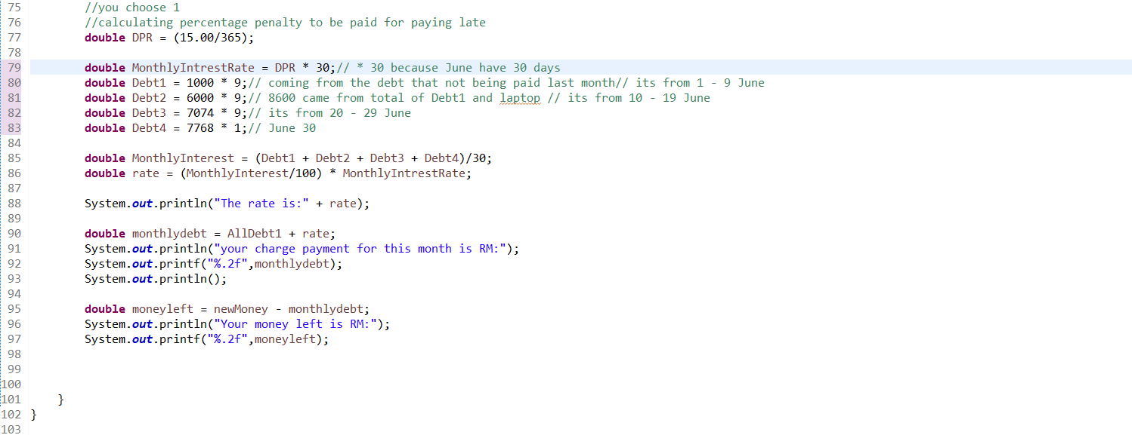

**OUTPUT:**

